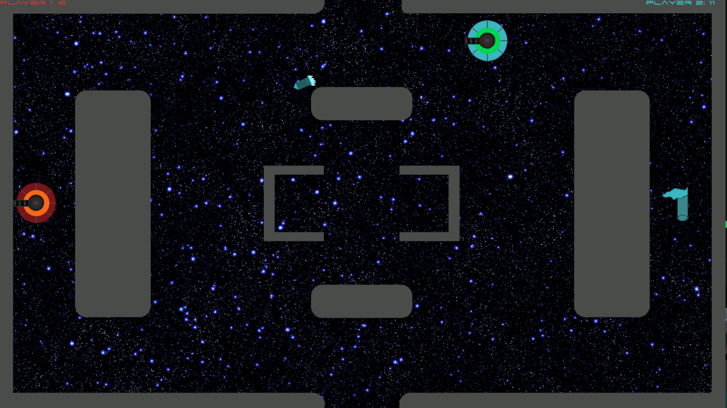

This Game was my second project Unity for my game design class. The goal is to attack the other player and if you hit them you get a point. The game had custom movement and projectile scrips, along with a “player seeking missile”. There are also gaps in the map where you go in one side and come out the other like in Pacman and flags for the other player to collect like capture the flag. The gameplay is fast paced and fun! Download the .exe to play.